Unit-3
Electric propulsion unit
Introduction to electrical components used in hybrid & electric vehicles
Configuration & control of Dc motor drives
Configuration & control of induction motor drives
1.1 Conventional ICE Vehicles:
The IC engine is a heat engine that converts chemical energy to mechanical energy. The transmission in the vehicle is a key component for power transfer from the IC engine to the wheels. The primary powertrain components in a conventional IC engine vehicle are the engine and the transmission. These components deliver power to the wheels through the driveshaft and other coupling devices. The coupling devices include the differential and final drive in most cases. This mechanical power transmission path (MPTP) is shown in Figure 1.1
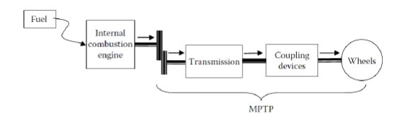
Fiqure 1.1 power train transmission path in conventional ICE vehicle

1.2 Electric Vehicles:
The electric machine can be used either as a motor or as a generator to convert mechanical power to electrical power or vice versa. The power transmission path in an electric vehicle is mostly electrical except for the coupling devices between the electric propulsion motor and the wheels. This power transfer path will be referred to as the electrical power transmission path (EPTP). This transmission path is shown in Figure 1.2. The coupling device can simply be a gear to match electric machine speeds to vehicle speeds.
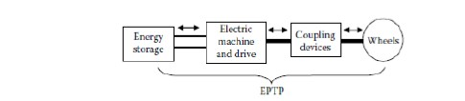
Fiqure 1.2 power transmission path in electric vehicle
1.3 Hybrid Electric Vehicles:
The electrical and mechanical transmission paths exist in the powertrain of a hybrid vehicle. The architecture and components of the powertrain of a hybrid electric vehicle is varied depending on the type of the hybrid vehicle. A generic configuration for a charge-sustaining hybrid is shown in Figure 1.3. The charge-sustaining hybrids are those that never need to be plugged in for recharging the energy storage system. The only energy source within the vehicle is the stored fuel for the IC engine. All of the propulsion energy gets processed through the engine regardless of whether the power transmission path is electrical or mechanical. The propulsion power comes from one or more electric motors and the IC engine. The propulsion power is transmitted to the wheels through either the MPTP or the EPTP, or the combination of the two. The MPTP is associated with an IC engine and transmission, whereas the EPTP consists of the energy storage system, a generator, a propulsion motor, and transmission. The combination of electric machines and IC engine and the arrangements of the power transmission paths give rise to a variety of architectures for hybrid electric Vehicles.
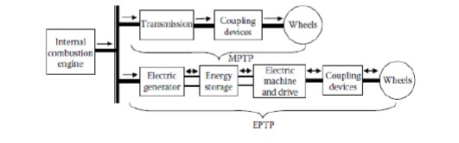
Fig 1.3 A hybrid electric vehicle power train
Electric propulsion systems
Electric propulsion systems are at the heart of EVs and HEVs. They consist of electric motors, power converters, and electronic controllers. The electric motor converts the electric energy into mechanical energy to propel the vehicle or vice versa, to enable regenerative braking and/or to generate electricity
for the purpose of charging the on-board energy storage. The power converter is used to supply the electric motor with proper voltage and current. The electronic controller commands the power converter by providing control signals to it, and then controls the operation of the electric motor to produce proper torque and speed, according to the command from the driver.
The electronic controller can be further divided into three functional units—sensor, interface circuitry, and processor. The sensor is used to translate the measurable quantities, such as current, voltage, temperature, speed, torque, and flux, into electric signals through the interface circuitry. These signals are conditioned to the appropriate level before being fed into the processor. The processor output signals are usually amplified via the interface circuitry to drive power semiconductor devices of the power converter. The functional block diagram of an electric propulsion system is illustrated in Figure 6.1
The choice of electric propulsion systems for EVs and HEVs mainly depends on a number of factors, including the driver’s expectation, vehicle constraints, and energy source. The driver’s expectation is defined by a driving profile, which includes the acceleration, maximum speed, climbing capability, braking, and range. The vehicle constraints, including volume and weight, depend on the vehicle type, vehicle weight, and payload. The energy source relates to batteries, fuel cells, ultra capacitors, flywheels, and various hybrid sources.
Thus, the process of identifying the preferred feature and package options for electric propulsion has to be carried out at the system level. The interaction of subsystems and the likely impacts of system trade-offs must be examined. Differing from the industrial applications of motors, the motors used in EVs and HEVs usually require frequent starts and stops; high rates of acceleration/ deceleration; high torque and low-speed hill climbing; low torque and high-speed cruising, and a very wide speed range of operation. The motor drives for EVs and HEVs can be classified into two main groups, namely the commutator motors and commutator less motors, as illustrated in Figure 6.2.
Commutator motors mainly are the traditional DC motors, which include
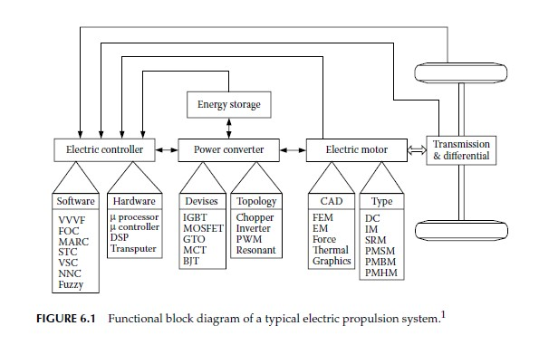
Series excited, shunt excited, compound excited, separately excited, and permanent magnets (PMs) excited motors. DC motors need commutators and brushes to feed current into the armature, thus making them less reliable and unsuitable for maintenance-free operation and high speed. In addition,
Winding-excited DC motors have low specific power density. Nevertheless, because of their mature technology and simple control, DC motor drives have been prominent in electric propulsion systems.
Technological developments have recently pushed commutator less electric motors into a new era. Advantages include higher efficiency, higher power density, and lower operating cost. They are also more reliable and maintenance-free compared to commutator DC motors; thus, commutator less electric motors have now become more attractive.
Induction motors are widely accepted as a commutatorless motor type for EV and HEV propulsion. This is because of their low cost, high reliability, and maintenance-free operation. However, conventional control of induction motors such as variable-voltage variable-frequency cannot provide
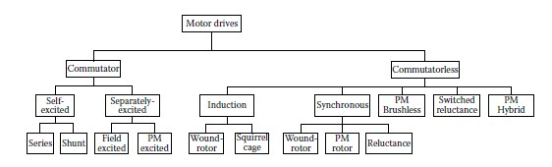
Fig 6.2 classification of electric motor drives for Ev and HEV applications the desired performance. With the advent of the power electronics and microcomputer era, the principle of field-oriented control (FOC) or vector control of induction motors has been accepted to overcome their control complexity
due to their nonlinearity.2 However, these EV and HEV motors using FOC still suffer from low efficiency at light loads and limited constant-power operating range.
By replacing the field winding of conventional synchronous motors with PMs, PM synchronous motors can eliminate conventional brushes, slip rings, and field copper losses.3 actually, these PM synchronous motors are also called PM brushless AC motors, or sinusoidal-fed PM brushless motors, because of their sinusoidal AC current and brushless configuration. Since these motors are essentially synchronous motors, they can run from a sinusoidal or pulsed waveform modulation supply (PWM supply) without electronic commutation. When PMs are mounted on the rotor surface, they behave as nonsalient synchronous motors because the permeability of PMs is similar to that of air. By burying those PMs inside the magnetic circuit of the rotor, the saliency causes an additional reluctance torque, which leads to facilitating a wider speed range at constant power operation. On the other hand, by abandoning the field winding or PMs while purposely making use of the rotor saliency, synchronous reluctance motors are generated. These motors are generally simple and inexpensive, but with relatively low output power.
Similar to induction motors, these PM synchronous motors usually use FOC for high-performance applications.3 Because of their inherently high power density and high efficiency, they have been accepted as having great potential to compete with induction motors for EV and HEV applications. By virtually inverting the stator and rotor of PM DC motors (commutator), PM brushless DC (BLDC) motors are generated. It should be noted that the term “DC” may be misleading, since it does not refer to a DC current motor.
Actually, these motors are fed by rectangular AC current and hence are also rectangular-fed PM brushless motors.4 The most obvious advantage of these motors is the removal of brushes. Another advantage is the ability to produce a large torque because of the rectangular interaction between current and flux. Moreover, the brushless configuration allows more cross-sectional area
for the armature windings. Since the conduction of heat through the frame is improved, an increase in electric loading causes higher power density. Different from PM synchronous motors, these PM BLDC motors generally operate with shaft position sensors. Recently, sensorless control technologies have
been developed in the Power Electronics and Motor Drive Laboratory at Texas A&M University
Switched reluctance motors (SRMs) have been recognized to have considerable potential for EV and HEV applications. Basically, they are direct derivatives of single-stack variable-reluctance stepping motors. SRMs have the definite advantages of simple construction, low manufacturing cost,
and outstanding torque–speed characteristics for EV and HEV applications. Although they possess simplicity in construction, this does not imply any simplicity of their design and control. Because of the heavy saturation of pole tips and the fringe effect of pole and slots, their design and control
are difficult and subtle. Traditionally, SRMs operate with shaft sensors to detect the relative position of the rotor to the stator. These sensors are usually vulnerable to mechanical shock and sensitive to temperature and dust.
Therefore, the presence of the position sensor reduces the reliability of SRMs and constrains some applications. Recently, sensorless technologies have been developed in the Power Electronics and Motor Drive Laboratory—again, at Texas A&M University. These technologies can ensure smooth operation from zero speed to maximum speed.5 This will be discussed in detail in the following sections
DC Motor Drives
DC motor drives have been widely used in applications requiring adjustable
speed; good speed regulation; and frequent starting, braking, and reversing.
Various DC motor drives have been widely applied to different electric
traction applications because of their technological maturity and control
simplicity.
Principle of Operation and Performance
The operation principle of a DC motor is straightforward. When a wire carrying
electric current is placed into a magnetic field, a magnetic force acting
on the wire is produced. The force is perpendicular to the wire and the magnetic
field as shown in Figure 6.3. The magnetic force is proportional to the
wire length, magnitude of the electric current, and the density of the magnetic
field; that is,
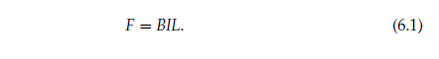
When the wire is shaped into a coil, as shown in Figure 6.3, the magnetic
forces acting on both sides produce a torque, which is expressed as
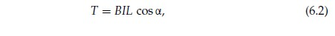
where α is the angle between the coil plane and the magnetic field as shown in
Figure 6.3. The magnetic field may be produced by a set of windings or PMs.
The former is called wound-field DC motor and the latter is called the PM DC
motor. The coil carrying electric current is called the armature. In practice,
the armature consists of a number of coils. In order to obtain continuous and
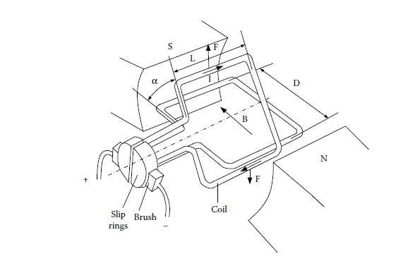
Fig 6.3 operation principle of a dc motor
maximum torque, slip rings and brushes are used to conduct each coil at the
position of α = 0.
Practically, the performance ofDCmotors can be described by the armature
voltage, back electromotive force (EMF), and field flux.
Typically, there are four types of wound-field DC motors, depending on
the mutual interconnection between the field and armature windings. They
are separately excited, shunt excited, series excited, and compound excited
as shown in Figure 6.4. In the case of a separately excited motor, the field
and armature voltage can be controlled independently of one another. In a
shunt motor, the field and armature are connected in parallel to a common
source. Therefore, an independent control of field or armature currents can
only be achieved by inserting a resistance in the appropriate circuit. This is an
inefficient method of control. The efficient method is to use power electronicsbased
DC–DC converters in the appropriate circuit to replace the resistance.
TheDC–DCconverters can be actively controlled to produce proper armature
and field voltage. In the case of a series motor, the field current is the same as
the armature current; therefore, field flux is a function of armature current.
In a cumulative compound motor, the magnetomotive force (mmf) of a series
field is a function of the armature current and is in the same direction as the
mmf of the shunt field.6
The steady-state equivalent circuit of the armature of a DC motor is shown
in Figure 6.5. The resistor Ra is the resistance of the armature circuit. For
separately excited and shunt DC motors, it is equal to the resistance of
the armature windings; for the series and compound motors, it is the sum
of armature and series field winding resistances. The basic equations of
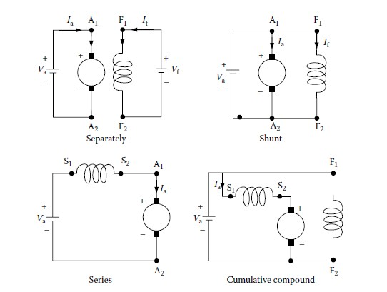
Fig 6.4 would field dc motors
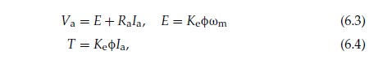
where φ is the flux per pole in webers, Ia is the armature current in A, Va is
the armature voltage in volts, Ra is the resistance of the armature circuit in
ohms, ωm is the speed of the armature in rad/s, T is the torque developed by
the motor in N m, and Ke is a constant.
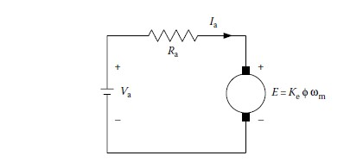
Fig 6.5 steady state equivalent circuit of the armature circuit of a Dc motor
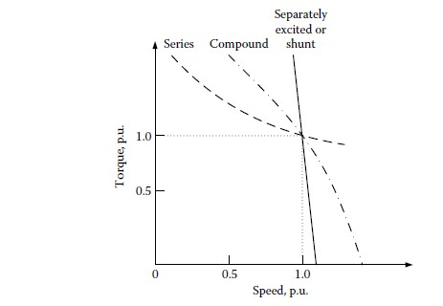
Fig 6.6 speed characteristics of Dc motors
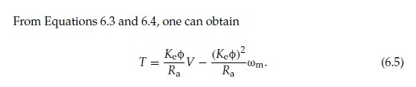
Equations 6.3 through 6.5 are applicable to all the DC motors, namely separately
(or shunt) excited, series, and compound motors. In the case of
separately excited motors, if the field voltage is maintained as constant, one
can assume the flux to be practically constant as the torque changes. In this
case, the speed–torque characteristic of a separately excited motor is a straight
line, as shown in Figure 6.6. The nonload speedωm is determined by the armature
voltage and the field excitation. Speed decreases as torque increases,
and speed regulation depends on the armature circuit resistance. Separately
excited motors are used in applications requiring good speed regulation and
proper adjustable speed.
In the case of series motors, the flux is a function of armature current. In an
unsaturated region of the magnetization characteristic, φ can be assumed to
be proportional to Ia. Thus

By Equations 6.4 through 6.6, the torque for series excited DC motors can
obtained as
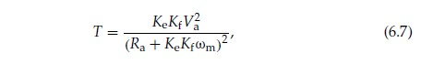

where the armature circuit resistance Ra is now the sum of armature and field
winding resistance.
A speed–torque characteristic of a series DC motor is shown in Figure 6.6.
In the case of a series, any increase in torque is accompanied by an increase in
the armature current and, therefore, an increase in magnetic flux. Because flux
increases with the torque, the speed drops to maintain a balance between the
induced voltage and the supply voltage. The characteristic, therefore, shows
a dramatic drop. A motor of standard design works at the knee point of the
magnetization curve at the rated torque. At heavy torque (large current) overload,
the magnetic circuit saturates and the speed–torque curve approaches
a straight line.
SeriesDCmotors are suitable for applications requiring high starting torque
and heavy torque overload, such as traction. This was just the case for electric
traction before the power electronics and micro-control era. However,
series DC motors for traction application bear some disadvantages. They
are not allowed to operate without the load torque with full supply voltage.
Otherwise, their speed will quickly increase up to a very high value (refer to
Equation 6.7) Another disadvantage is the difficulty of regenerative braking.
Performance equations for cumulative compound DC motors can be
derived from Equations 6.3 and 6.4. The speed–torque characteristics are
between series and separately excited (shunt) motors, as shown in Figure 6.6.
6.1.2 Combined Armature Voltage and Field Control
The independence of armature voltage and field provides more flexible control
of the speed and torque than other types of DC motors. In EV and HEV
applications, the most desirable speed–torque characteristic is to have a constant
torque below a certain speed (base speed), and a constant power in the
speed range of above the base speed, as shown in Figure 6.7. In the speed
range of lower than the base speed, the armature current and field are set at
their rated values, producing the rated torque. From Equations 6.3 through
6.4, it is clear that the armature voltage must be increased proportionally with
the increase of the speed. At the base speed, the armature voltage reaches its
rated value (equal to the source voltage) and cannot be increased further.
In order to further increase the speed, the field must be weakened with the
increase of the speed, then maintaining the back EMF E and armature current
constant. The torque produced drops parabolically with the increase of the
speed and the output power remains constant, as shown in Figure 6.7.
6.1.3 Chopper Control of DC Motors
Choppers are used for the control of DC motors because of a number of
advantages such as high efficiency, flexibility in control, light weight, small
size, quick response, and regeneration down to very low speeds. At present,
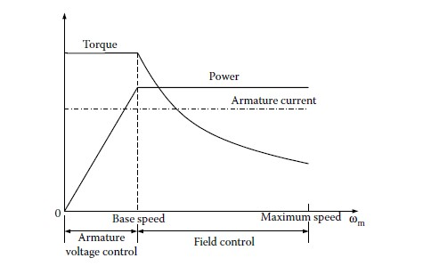
Fig 6.7 torque and power limitation in combined armature voltage and field control
the separately excited DC motors are usually used in traction, due to the
control flexibility of armature voltage and field.
For a DC motor control in open-loop and closed-loop configurations, the
chopper offers a number of advantages due to the high operation frequency.
High operation frequency results in high-frequency output voltage ripple
and therefore less ripples in the motor armature current and a smaller region
of discontinuous conduction in the speed–torque plane. A reduction in the
armature current ripple reduces the armature losses. Areduction or elimination
of the discontinuous conduction region improves speed regulation and
transient response of the drive.
The power electronic circuit and the steady-state waveform of aDCchopper
drive are shown in Figure 6.8. ADC voltage source, V, supplies an inductive
load through a self-commutated semiconductor switch S. The symbol of a selfcommutated
semiconductor switch has been used because a chopper can be
built using any devices among thyristors with a forced commutation circuit:
GTO, power transistor, MOSFET, and IGBT. The diode shows the direction
in which the device can carry current. A diode DF is connected in parallel
with the load. The semiconductor switch S is operated periodically over a
period T and remains closed for a time ton = δT with 0 < δ < 1. The variable
δ = ton/T is called the duty ratio or duty cycle of a chopper. Figure 6.8 also
shows the waveform of control signal ic. Control signal ic will be the base
current for a transistor chopper, and a gate current for the GTO of a GTO
chopper or the main thyristor of a thyristor chopper. If a power MOSFET is
used, it will be a gate to the source voltage. When the control signal is present,
the semiconductor switch S will conduct, if forward biased. It is assumed that
the circuit operation has been arranged such that the removal of ic will turn
off the switch.
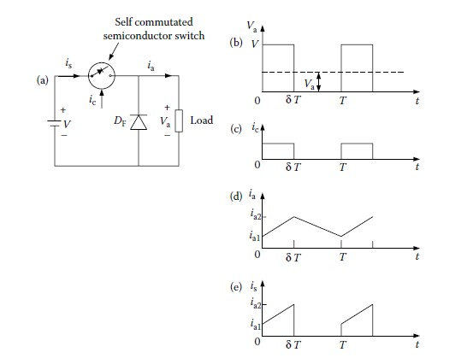
Fig 6.8 priciple of operation of a step down(or class A) chopper
(a) basic chopper circuit
(b)-(e) wave forms
During the on interval of the switch (0 ≤ t ≤ δT), the load is subjected to a
voltage V and the load current increases from ia1 to ia2. The switch is opened
at t = δT. During the off period of the switch (δT ≤ t ≤ 1), the load inductance
maintains the flow of current through diode DF. The load terminal voltage
stays zero (if the voltage drop on the diode is ignored in comparison toV) and
the current decreases from ia2 to ia1. The internal 0 ≤ t ≤ δT is called the duty
interval and the interval δT ≤ t ≤ T is known as the freewheeling interval.
Diode DF provides a path for the load current to flow when switch S is off,
and thus improves the load current waveform. Furthermore, by maintaining
the continuity of the load current at turn-off, it prevents transient voltage from
appearing across switch S, due to the sudden change of the load current. The
source current waveform is also shown in Figure 6.8e. The source current
flows only during the duty interval and is equal to the load current.
The direct component or average value of the load voltage Va is given by
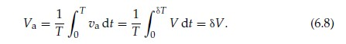
By controlling δ between 0 and 1, the load voltage can be varied from 0 to
V; thus a chopper allows a variable DC voltage to be obtained from a fixed
voltage DC source.
The switch S can be controlled in various ways for varying the duty ratio δ.
The control technologies can be divided into two categories:
1. Time Ratio Control (TRC).
2. Current Limit Control (CLC).
In TRC, also known as pulse width control, the ratio of on time to chopper
period is controlled. The TRC can be further divided as follows:
1. Constant frequency TRC: The chopper period T is kept fixed and the on
period of the switch is varied to control the duty ratio δ.
2. Varied frequency TRC: Here δ is varied either by keeping ton constant
and varying T or by varying both ton and T.
In variable frequency control with constant on time, low-output voltage
is obtained at very low chopper frequencies. The operation of a chopper
at low frequencies adversely affects the motor performance. Furthermore,
the operation of a chopper with variable frequencies makes the design
of an input filter very difficult. Thus, variable frequency control is rarely
used.
In CLC, also known as point-by-point control, δ is controlled indirectly
by controlling the load current between certain specified maximum and
minimum values. When the load current reaches a specified maximum
value, the switch disconnects the load from the source and reconnects it
when the current reaches a specified minimum value. For a DC motor
load, this type of control is, in effect, a variable frequency variable on time
control.
The following important points can be noted from the waveform of
Figure 6.8.
1. The source current is not continuous but flows in pulses. The pulsed
current makes the peak input power demand high and may cause
fluctuation in the source voltage. The source current waveform can be
resolved into DC and AC harmonics. The fundamental AC harmonic
frequency is the same as the chopper frequency. TheACharmonics are
undesirable because they interfere with other loads connected to the
DC source and cause radio frequency interference through conduction
and electromagnetic radiation. Therefore, an L-C filter is usually
incorporated between the chopper and theDCsource.At higher chopper
frequencies, harmonics can be reduced to a tolerable level by a
cheaper filter. From this point, a chopper should be operated at the
highest possible frequency.
2. The load terminal voltage is not a perfect direct voltage. In addition to
a direct component, it has the harmonics of the chopping frequency
and its multiples. The load current also has an AC ripple.
The chopper of Figure 6.8 is called a classAchopper. It is one of the number
of chopper circuits that are used for the control of DC motors. This chopper is
capable of providing only a positive voltage and a positive current. It is called a
single-quadrant chopper, only providing separately excitedDCmotor control
in the first quadrant, that is, positive speed and positive torque. Since it can
vary the output voltage from V to 0, it is also a step-down chopper or a DCto-
DC buck converter. The basic principle involved can also be used to realize
a step-up chopper or DC-to-DC boost converter.
The circuit diagram and steady-state waveforms of a step-up chopper are
shown in Figure 6.9. This chopper is known as a class B chopper. The presence
of control signal ic indicates the duration for which the switch can conduct if
forward-biased. During a chopping period T, it remains closed for an interval
0 ≤ t ≤ δT and remains open for an interval δT ≤ t ≤ T. During the on period,
iS increases from iS1 to iS2, thus increasing the magnitude of energy stored in
inductance L. When the switch is opened, current flows through the parallel
combination of the load and capacitor C. Since the current is forced against
the higher voltage, the rate of change of the current is negative. It decreases
from iS2 to iS1 in the switch’s off period. The energy stored in the inductance
L and the energy supplied by the low-voltage source are given to the load.
The capacitor C serves two purposes. At the instant of opening of switch S,
the source current, iS, and load current, ia, are not the same. In the absence of
C, the turn-off of S will force the two currents to have the same values. This
will cause high induced voltage in the inductance L and the load inductance.
Another reason for using capacitor C is to reduce the load voltage ripple. The
purpose of the diode D is to prevent any flow of current from the load into
switch S or source V.
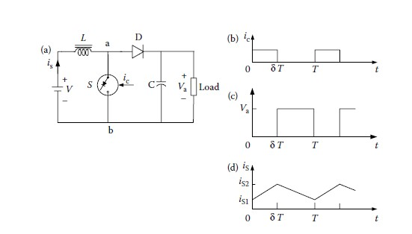
Fig 6.9 principle of operation of a step up (or class B ) chopper
(a) basic chopper circuit
(b-d) wave forms
For understanding of the step-up operation, capacitor C is assumed large
enough to maintain a constant voltageVa across the load. The average voltage
across the terminals a and b is given as
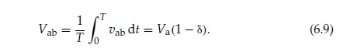
The average voltage across the inductance L is
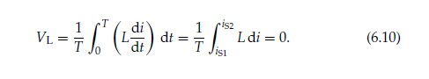
The source voltage
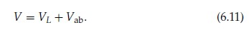
Substituting from Equations 6.9 and 6.10 into Equation 6.11 gives
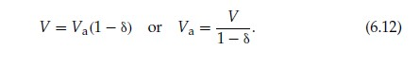
According to Equations 6.12, theoretically the output voltage Va can be
changed from V to ∞ by controlling δ from 0 to 1. In practice, Va can be
controlled from V to a higher voltage, which depends on the capacitor C, and
the parameters of the load and chopper.
The main advantage of a step-up chopper is the low ripple in the source
current. While most applications require a step-down chopper, the step-up
chopper finds application in low-power battery-driven vehicles. The principle
of the step-up chopper is also used in the regenerative braking of DC motor
drives.
6.1.4 Multi-Quadrant Control of Chopper-Fed DC Motor Drives
The application ofDCmotors on EVs andHEVsrequires the motors to operate
in multiquadrants, including forward motoring, forward braking, backward
motoring, and backward braking, as shown in Figure 6.10. For vehicles with
reverse mechanical gears, two-quadrant operation (forward motoring and
forward braking, or quadrant I and quadrant IV) is required. However, for
the vehicles without reverse mechanical gears, four-quadrant operation is
needed. Multiquadrant operation of a separately excited DC motor is implemented
by controlling the voltage poles and magnitude through power
electronics-based choppers.
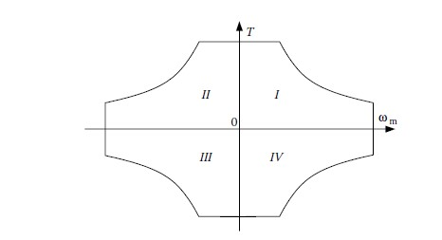
Fiqure 6.10 speed torque profiles of a multi quadrant operation
6.1.4.1 Two-Quadrant Control of Forward Motoring
and Regenerative Braking
Atwo-quadrant operation consisting of forwardmotoring and forwardregenerative
braking requires a chopper capable of giving a positive voltage and
current in either direction. This two-quadrant operation can be realized in the
following two schemes. 6.1.4.1.1 Single Chopper with a Reverse Switch
The chopper circuit used for forward motoring and forward regenerative
braking is shown in Figure 6.11 where S is a self-commutated semiconductor
switch, operated periodically such that it remains closed for a duration of δT
and remains open for the duration of (1 − δ)T. C is the manual switch. When
C is closed and S is in operation, the circuit is similar to that of Figure 6.6,
permitting the forward motoring operation. Under this condition, terminal a
is positive and terminal b is negative.
The regenerative braking in the forward direction is obtained when C is
opened and the armature connection is reversed with the help of the reversing
switch RS, making terminal b positive and terminal a negative. During the on
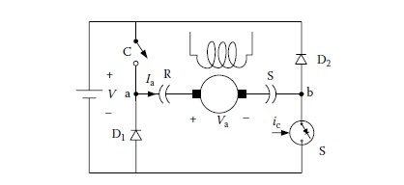
Fig 6.11 forward motoroing and regenerative braking control with a single chopper
period of the switch S, the motor current flows through a path consisting of the
motor armature, switch S, and diode D1, and increases the energy stored in
the armature circuit inductance. When S is opened, the current flows through
the armature diode D2, source V, diode D1 and back to the armature, thus
feeding energy into the source.
During motoring, the change over to regeneration is done in the following
steps. Switch S is deactivated and switchCis opened. This forces the armature
current to flow through diode D2, source V and diode D1. The energy stored
in the armature circuit is fed back to the source and the armature current falls
to zero. After an adequate delay to ensure that the current has indeed become
zero, the armature connection is reversed and switch S is reactivated with a
suitable value of δ to start regeneration.
6.1.4.1.2 Class C Two-Quadrant Chopper
In some applications, a smooth transition from motoring to braking and vice
versa is required. For such applications, the class C chopper is used as shown
in Figure 6.12. The self-commutated semiconductor switch S1 and diode D1
constitute one chopper and the self-commutator switch S2, and diode D2
form another chopper. Both the choppers are controlled simultaneously, both
for motoring and regenerative braking. The switches S1 and S2 are closed
alternately. In the chopping period T, S1 is kept on for a duration δT and
S2 is kept on from δT to T. To avoid a direct short-circuit across the source,
care is taken to ensure that S1 and S2 do not conduct at the same time. This
is generally achieved by providing some delay between the turn-off of one
switch and the turn-on of another switch.
The waveforms of the control signals, va, ia, and is and the devices under
conducting during different intervals of a chopping period are shown in
Figure 6.11b. In drawing these waveforms, the delay between the turn-off
of one switch and turn-on of another switch has been ignored because it is
usually very small. The control signals for the switches S1 and S2 are denoted
by ic1 and ic2, respectively. It is assumed that a switch conducts only when
the control signal is present and the switch is forward biased.
The following points are helpful in understanding the operation of this
two-quadrant circuit.
1. In this circuit, discontinuous conduction does not occur, irrespective of
its frequency of operation. The discontinuous conduction occurs when
the armature current falls to zero and remains zero for a finite interval
of time. The current may become zero either during the freewheeling
interval or in the energy transfer interval. In this circuit, freewheeling
will occur when S1 is off and the current is flowing through D1.
This will happen in interval δ T ≤ t ≤ T, which is also the interval for
which S2 receives the control signal. If ia falls to zero in the freewheeling
interval, the back EMF will immediately drive a current through
S2 in the reverse direction, thus preventing the armature current from
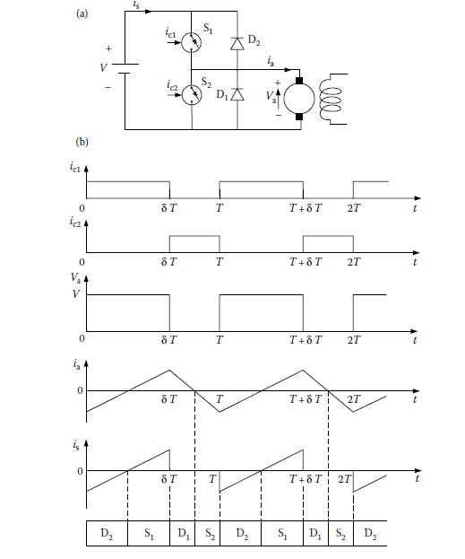
Fig 6.12 forward motoring and regenerative braking control using class c two quadrant chopper
a)chopper circuit b) wave forms
remaining zero for a finite interval of time. Similarly, the energy transfer
will be present when S2 is off andD2 is conducting—that is, during
the interval 0 ≤ t ≤ δT. If the current falls to zero during this interval,
S1 will conduct immediately because ic is present and V > E. The
armature current will flow, preventing discontinuous conduction.
2. Since discontinuous conditions are absent, the motor current will be
flowing all the time. Thus, during the interval 0 ≤ t ≤ δT, the motor
armature will be connected either through S1 orD2. Consequently, the
motor terminal voltage will be Vand the rated of change of ia will be
positive because V > E. Similarly, during the interval δT ≤ t ≤ T, the
motor armature will be shorted either throughD1 or S2. Consequently,
the motor voltage will be zero and the rate of change of ia will be
negative.
3. During the interval 0 ≤ t ≤ δT, the positive armature current is carried
by S1 and the negative armature current is carried by D2. The
source current flows only during this interval and it is equal to ia.
During the interval δT ≤ t ≤ T, the positive current is carried by D1
and the negative current is carried by S2.
4. From the motor terminal voltage waveform of Figure 6.12b, Va = δV.
Hence
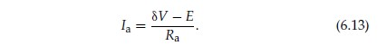
Equation 6.13 suggests that the motoring operation takes place when
δ > (E/V), and that regenerative braking occurs when δ < (E/V). The
no-load operation is obtained when δ = (E/V).
6.1.4.2 Four-Quadrant Operation
The four-quadrant operation can be obtained by combining two class C choppers
(Figure 6.12a) as shown in Figure 6.13, which is referred to as a class E
chopper. In this chopper, if S2 is kept closed continuously, and S1 and S4 are
controlled, a two-quadrant chopper is obtained, which provides positive terminal
voltage (positive speed) and the armature current in either direction
(positive or negative torque), giving a motor control in quadrants I and IV.
Now if S3 is kept closed continuously and S1 and S4 are controlled, one gets
a two-quadrant chopper that can supply a variable negative terminal voltage
(negative speed), and the armature current can be in either direction (positive
or negative torque), giving a motor control in quadrants II and III.
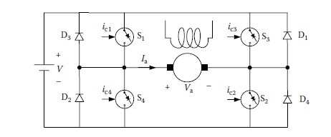
Fig 6.13 class E four quadrant chopper
This control method has the following features: the utilization factor of
the switches is low due to the asymmetry in the circuit operation. Switches
S3 and S2 should remain on for a long period. This may create commutation
problems when the switches are using thyristors. The minimum output
voltage depends directly on the minimum time for which the switch can be
closed, since there is always a restriction on the minimum time for which
the switch can be closed, particularly in thyristor choppers.7 The minimum
available output voltage, and therefore the minimum available motor speed,
is restricted.
To ensure that switches S1 and S4, or S2 and S3 are not on at the same time,
some fixed time interval must elapse between the turn-off for one switch
and the turn-on of another switch. This restricts the maximum permissible
frequency of operation. It also requires two switching operations during a
cycle of the output voltage.
Dubey6 provided other control methods to solve the problems mentioned
above.

